Montgomery Chapter AGA
Member Centric Report
Program Year 2017-2018






Miss
Membership
Government | 246 |  | CGFM | 58
Private | 11 |  | CPA | 34
Early Career | 6 |  | CIA | 4
Students | 2 |  | CFE | 8
Retired/ Lifetime | 5 |  | Other | 12

About the Montgomery Chapter of AGA
The Montgomery Chapter of AGA serves Federal, State, County and Local Governments, accounting and auditing employees as well as private sector accountants, and academia working primarily in the metropolitan Montgomery, Alabama area.
The Montgomery Chapter is guided by an elected President, President Elect, Treasurer, Financial Secretary, Secretary and Assistant Secretary. The Chapter functions under directors who comprise the Chapter Executive Committee (CEC). Each director has committee members, that help the respective director to facilitate the initiatives brought forth by the CEC. The Chapter Executive Committee’s charge is to recruit and retain members while providing continuing education, promoting certification of the Certified Government Financial Manager, hosting public service events, encouraging participation by Young Professionals and hosting membership drives. The continued mission of the Chapter is to promote best practices and accountability in all areas of government and the private sector.

Message about the Montgomery AGA Chapter, Program Year 2017-2018
Hello, welcome to the Montgomery AGA Chapter. The theme for the 2017-2018 program year was “Serving Our AGA with passion and purpose”. This theme called every member of AGA to take ownership in the organization and help execute the mission of the organization based on each member’s unique talents, skills, and interest. We had a great year, with increased CPE’s offered through conferences, workshops, and live stream events. As a chapter we participated in meetings and events at colleges and universities, to promote careers in financial management, provided free resources to CGFM candidate, maximized member value through various social media platforms and held a membership appreciation luncheon. We actively participated in community service events, provided an excellence in accountability platform at the Fall PDT, and identified opportunities to support the effectiveness and efficiency of the chapter. This was done by auditing our website and identifying new policies, procedures, and processes.

December Luncheon
September Luncheon
Table of Contents
Montgomery Chapter Page 1
Accomplishments and
Performance Measurers Page 2
Chapter Finances Page 3
What is Next? Challenges
Moving Forward Page 4
Vision
The Montgomery Chapter of AGA is to become a leader in recruitment of new members and encourage participation in continuing education and certification.
Mission
The mission of AGA is to be the premier professional association in the advancement of accountability, transparency and leadership by promoting education, certification, innovation and collaboration across all levels of government and to stakeholders.

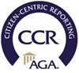

Margie Toney and Ashley Mc Tear, at the PDT in Orlando
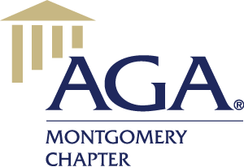
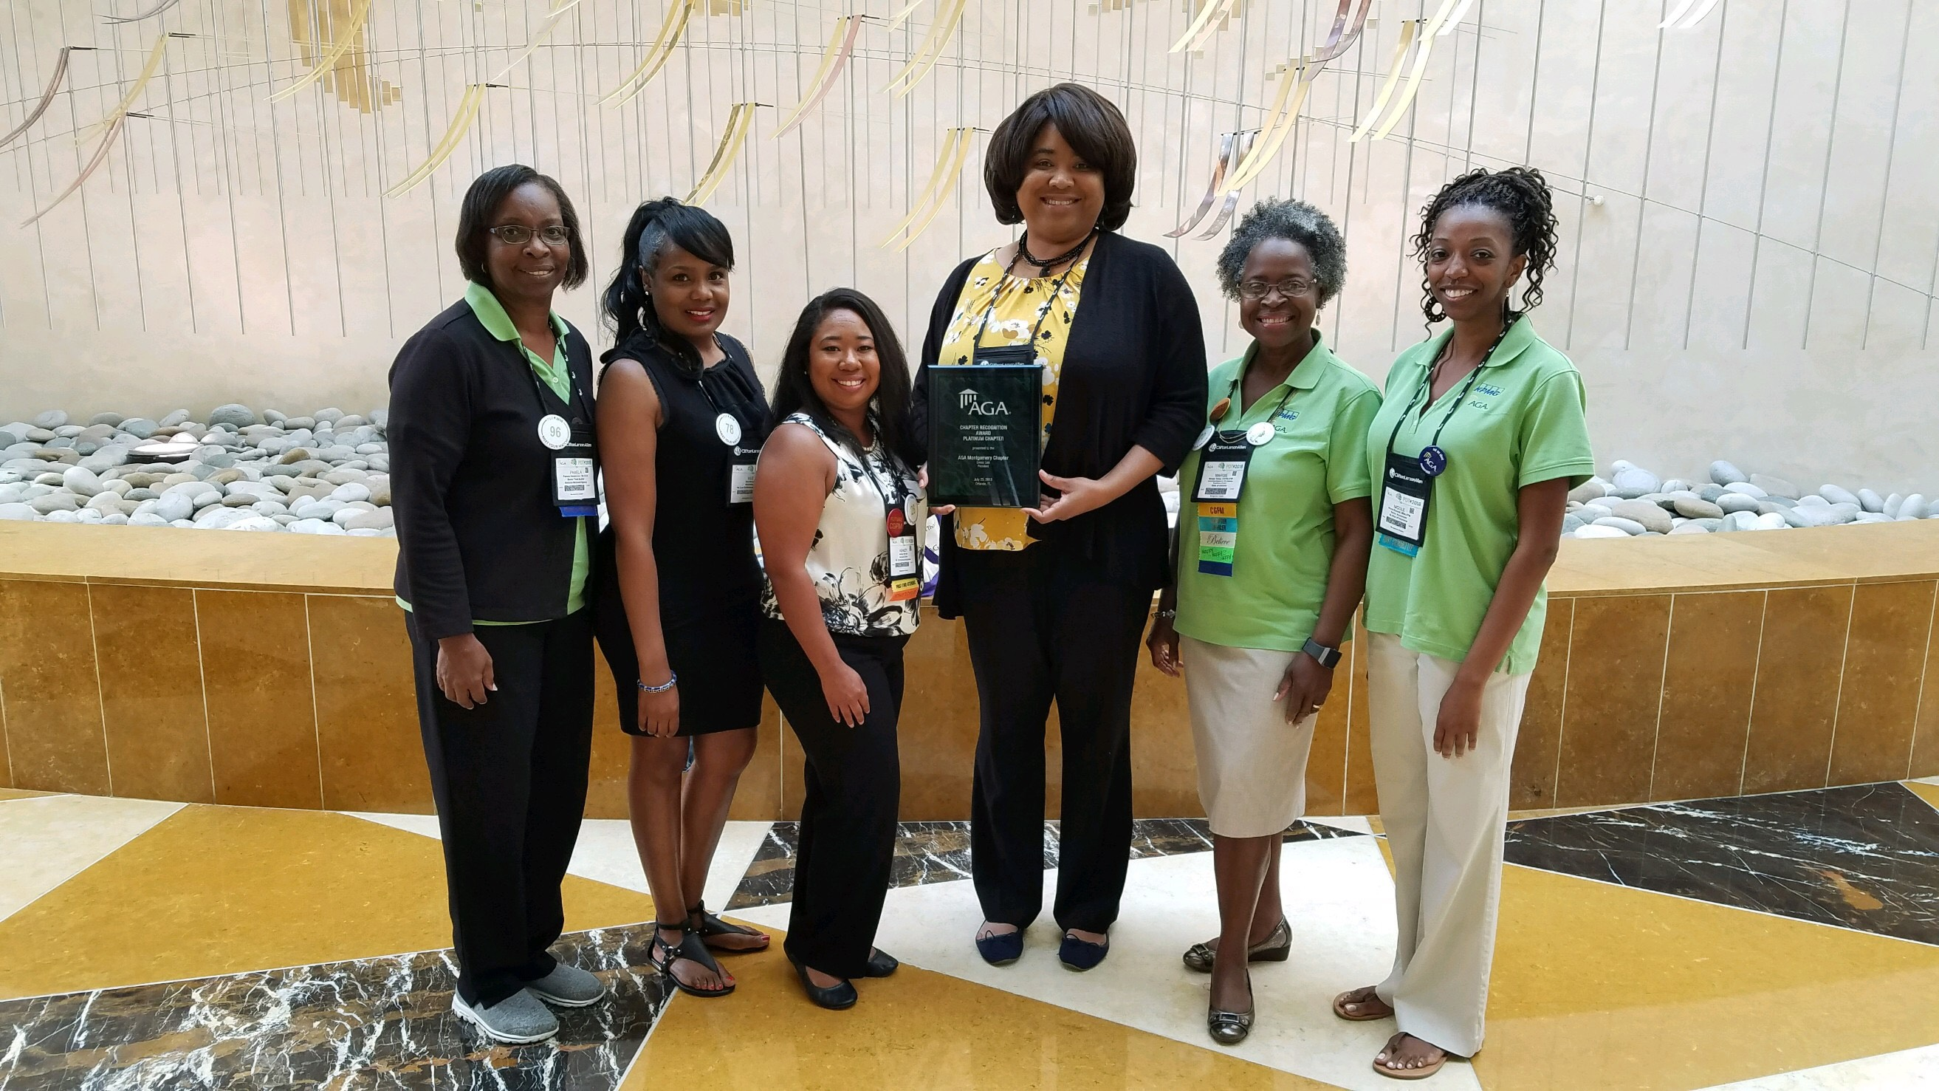


Accomplishments and Performance Measurers


Montgomery Chapter  Performance Measures | 2018  Actual | 2017  Actual | Percentage  Of Change
Membership
Total number of Members | 270 | 350 | -23%
Education
Number of CPEs offered during the program year | 59 | 20 | 66%
Number of Mentoring Programs  And workshops | 10 | 4 | 60%
Meetings and Conferences
Average number attending monthly meetings | 51 | 62 | -18%
Number attending Spring Seminar | 154 | 164 | -6%
Number attending Fall Seminar | 223 | 275 | -19%
Certification
Members obtaining CGFM certification | 1 | 2 | -50%
Number of Proclamations | 7 | 15 | -53%
Community Service
Community Service Events | 7 | 8 | -12%

Accomplishments for Program Year 2017-2018
The Montgomery Chapter received the Platinum Award at the 2018 PDT in Orlando, Florida for chapter recognition points for Group A.
President Emma Cole was a speaker at and attended workshops to inspire high school and college students to get involved and pursue careers in accounting.
Mr. Bob Childree, will serve on the national AGA Financial Management Standards Board for program year 2018-2019.
The Montgomery Chapter AGA held the Fall Profession Development Training jointly with the Institute of Internal Auditors.
The Membership and Early Career Committee participated in Accountancy Day held at Auburn University in Montgomery to expose students to careers in government.
The CGFM Committee held a workshop for CGFM month, to recognize members with the CGFM designation.
The Membership Committee held a member appreciation luncheon, that included great speakers. The Membership Committee also had an Appreciation Month table in one of the state employee buildings. The Appreciation Month table allowed government employees to obtain information about AGA. This event reclaimed old members and signed up new members.

President Cole and AGA members at PDT
CGFM Month
Community Service, Zoo event


Montgomery AGA Chapter Finances

Chapter Revenue and Expenditures
The Montgomery Chapter AGA receives funds from AGA National to help the Chapter with Membership and Recruitment. The majority of, revenues are received from educational events such as the Fall Seminar and Spring Seminar. The table and graph include various sources of revenue and expenditures in the following program years.
Revenue by Source

on | 2017 | 2018
Audio Conf./Workshops | $0.00 | $1,513.00
Community Service | $1,012.00 | $0.00
Education | $57,382.00 | $36,925.00
Luncheon//Meetings | $2,972.50 | $1,681.00
Membership Dues | $1,023.34 | $2,824.15
Membership Recruitment/ Early Career | $00.00 | $0.00
Miscellaneous | $5,350.75 | $4,054.07
Sponsorships | $00.00 | $3,500.00
Total Primary Chapter Revenues | $67,740.59 | $50,497.22
Expenses
 | 2017 | 2018
Audio Conf./Lecturer Series/Webinars | $0.00 | $1,128.12
Awards and Scholarships | $2,029.73 | $2,250.00
Community Service | $1,251.89 | $0.00
Education | $23,368.83 | $20,098.45
Luncheons/Meetings | $4,550.76 | $1,944.37
Membership and Mentorship | $654.49 | $0.00
Membership Dues (National) | $21,700.00 | $0.00
Miscellaneous | $6,758.95 | $6,841.71
Regional PDC Registration & Travel | $4,625.72 | $154.40
Printing/Office Supplies/Postage | $64.54 | $1,934.62
Webpage and Technology | $1,224.95 | $1,224.95
Total Primary Chapter Expenses | $66,232.86 | $35,576.62
The Financial records for the Montgomery Chapter of AGA are currently being reviewed by, the firm of Wealth Management Partners Certified Public Accountants LLC.


What is next? Challenges Moving Forward
Increasing Membership and Retention
The Montgomery AGA Chapter currently has 270 members. The goal is to increase the Montgomery Chapter membership to 300 members. The challenges of this committee are creating new and innovative ways to attract new members and to help prospective members see the advantages of membership in AGA. The goals of this committee are:
- To retain current members and provide promotional materials on the benefits of being an AGA member. To spotlight successful members in the Chapter Newsletter. To contact retired members and encourage them to renew their membership;
- To engage and support the Chapter’s Young Professional Advisory Board by providing social development and educational opportunities for YP members through luncheons, social events, and conducting projects and events that are specifically targeted to and/or hosted by YP members;
- To expand our relationship with local educational institutions and encourage faculty to become members of AGA and, also provide a job shadow day for student members that participate in the local Universities Accounting Clubs.
Certified Government Financial Manager
The CGFM Committee will promote the CGFM certification and assist candidates in preparing for the exams and act as a resource for CGFM information while increasing CGFM candidates. The goals of this committee are:
- To develop strategies to increase the number of CGFM candidates, by providing study groups and supporting materials to prepare and pass all the CGFM examinations;
- To display brochures at luncheon and seminars, also assist in identifying CPE opportunities through online study, seminars and self- study, publish member achievements in the chapter newsletter, local papers and websites;
- To communicate and coordinate with other committees in identifying, supporting, and recognizing new CGFM candidates.
Mentorship
The Montgomery Chapter Mentorship Committee is challenged with increasing participation of members and nonmembers in the mentoring programs. The goals of this committee are:
- To provide mentees with training and resources to develop skills and characteristics to become successful professional leaders;
- To promote and advertise the mentorship program to AGA members, colleges, high schools and community organizations;
- To assist the Membership Committee with promoting the benefits of being an AGA member to the Young Professionals and maintaining membership to AGA.
Education
The Education Committee is challenged with increasing the number of affordable continuing education opportunities to AGA members. The goals of this committee are:
- To increase the number of CPE credits offered annually and promote the webinars and educational events hosted by AGA National and the Journal online quizzes to earn CPE;
- To partner with other organizations to increase the number of participants thereby making it more cost effective to attend educational events;
- To secure sponsorships to support the educational programs conducted throughout the year;
- To include Chapter educational events on the National AGA online calendar of events, social media, brochures, and the Chapter Website.

“Serving Our AGA with Passion and Purpose”
-Emma Cole
Community Service Event to help women and children that are victims of domestic abuse.

We would like to hear from you
Do you like this report? If you would like to see other information or if you would like more information on our services, visit our website at: www.montgomeryaga.org. Follow us on: Facebook, Twitter, and LinkedIn
Chapter Officer Directory
President Emma Cole
President –Elect Courtney Bruce
Treasurer LaTreeka Williams
Financial Sec Ann Franklin
Secretary Dixie Black
Asst. Secretary LaTreeka Williams
Immediate Past President Marcus Johnson

