Citizen Centric Report
Report to our Members
Montgomery AGA Chapter
Program Year 2021-2022



Message from our Chapter President
Our primary focus for the 2021-2022 year was to get our members back together in person. To build back a void that was missing with a lack of in person fellowship and networking, while still providing quality CPE opportunities to members that were unable to attend in person events. Our Spring Conference registration reflected the desire of our members to get back together. During the Conference we attained a larger member registration than most all our Chapter’s pre-covid events. We had participation of 140 members in person and 50 members virtually.
In all the 2021-2022 year, we provided a total of approximately 28 hours of CPE, 4 of which were free to members. These hours were provided by virtual lunch and learn, a virtual fall PDT, and a hybrid spring PDT.
We continued to support and promote the CGFM Certification by recognizing CGFM's and providing door gifts to CGFM's during the Spring Conference and hosting a CGFM panel discussion that was free to members and a minimal cost to non-members. In addition, our Chapter continued to provide scholarships to reimburse members that passed a portion of the CGFM exam. Total CGFM scholarships distributed during the 2021-2022 fiscal year were approximately $2,600. In addition to the CGFM scholarships, our Scholarship Committee granted a total of $4,000 in scholarships to upcoming college freshmen and to state government employees for higher education. These scholarships ranged from $500 to $750 each. Our accountability committee also made a $350 scholarship to an accounting essay scholarship recipient.
Our Community Service Committee's efforts picked back up as we were coming out of COVID. During the fall of 2021, our local chapter participated in a local non-profit's 5k fun run, benefiting the Brantwood Children’s Home. We also made a sizable food donation to Brantwood. Our sponsored charity for the Spring Conference was the Family Sunshine Center. In total, our chapter contributed approximately $1,500 to local charities during the 2021-2022 fiscal year.
It takes a village to keep our local Montgomery AGA Chapter thriving. Our chapter has multiple dedicated members that selflessly volunteer their time and talents to make our chapter a success. Each of our committee members are dedicated to their roles and take pride in the work they do. This work didn't go unnoticed by Nationals. In fact, our chapter received the Platinum Award from Nationals due all our chapter volunteer’s efforts.
It was an honor and blessing to service as Chapter President and I look forward to continuing serving with future leaders.
Respectively, Jonathan West

Contents
Overview Page 1
Performance Measurers Page 2
Finances Page 3
What is Next? Page 4

Our Mission
AGA Core Values
Service
Accountability
Integrity
Leadership


Chapter President, Jonathan West
Our Vision
Chapter Membership | FY 2022 | FY 2021
Government | 251 | 248
Private | 10 | 10
Retired/Lifetime | 5 | 5
Young Professional | 40 | 5
CGFM | 68 | 64
CPA | 37 | 37
CIA | 5 | 5
CFE | 7 | 7
Other | 15 | 15

The mission of AGA is to be the premier professional association in the advancement of accountability, transparency and leadership by promoting education, certification, innovation and collaboration across all levels of government and stakeholders.
The Montgomery Chapter of AGA is striving to become a leader in recruitment of new members and encourage participation in continuing education and certification.
Accomplishments and Performance Measurers

Key Performance Measurers
Montgomery Chapter Performance Measurers | Program Year 2022 | Program Year 2021 | Percentage of Change
Education | CPE Hours Offered | CPE Hours Offered
The Chapter held luncheon meetings and Fall PDT virtually due to COVID-19 concerns and mandates with some offering in person attendance. Spring PDT provided for a live option which resulted in an increased participation rate and membership growth. The Education Committee continued to recruit engaging and well-informed speakers including, Mayor Steven Reed, Billy Morehead, the AGA National President, and multiple Senior Directors from various state agencies. | 28 | 16.2 | 72%
Certification | Number of new CGFM | Number of new CGFM
The CGFM Committee encouraged members to achieve the CGFM certification via E-mail Communication, Newsletters, and Mentoring. The Panel Discussion (March 10, 2022), “The Value & Benefits of the CGFM® Certification” featured the following chapter CGFMs: Margie Toney, Reneé S. Reese, Charlene F. Wachs, & Jonathan West. | 4 | 4 | 0%
Community Service | Projects | Projects
Community Service had an awesome year. This year our charities were Brantwood Children Home, AUM Veteran's Association, Usborne Books & More, and Family Sunshine Center. Donations were received for Brantwood during the Fall PDT. Spring PDT will be the Montgomery Area Food Bank. | 5 | 5 | 0%
Membership | Members | Members
The Membership Committee’s focus was customer service. This committee worked with the treasurer to make sure membership dues were paid in a timely manner and assisted in reconciling the financial reports. This committee was also committed to establishing a system for the members to communicate with the committee and receive a timely response. | 306 | 268 | 14%

Accomplishments
The Montgomery Chapter received the Platinum Award for program year 2021-2022.
Mrs. LaTreeka Williams has been selected as the National Chair Representative for the Montgomery Chapter for program year 2021-2022.
The Accountability Committee received the Certificate of Excellence in Citizen Centric Reporting for the Montgomery Chapter Member Centric Report for program year 2020-2021.
The Community Service Committee gave Cuddle Bears to Baptist South NICU for Pediatric Cancer Awareness Month, donated money and various items to Brantwood, purchased various items for Veteran's for Veteran’s Day, Spring PDT we will collect can goods.
The Accountability Committee joined with the Membership Committee to host the Montgomery Chapter’s Accounting Student Essay Contest for college students. The winner was Ms. Abigail Williams from Auburn University at Montgomery.
The CGFM Committee honored chapter CGFMs during the month of March 2022, by publishing their names in the chapter newsletter & via a PowerPoint Presentation. The CGFMs were also presented with CGFM logo tumblers as tokens of appreciation. We were awarded a total of $2,600 in CGFM® Reimbursement Scholarships to nine (9) different candidates, during PY 2022. This amount represents a 103% increase in the PY 2021 total ($295).


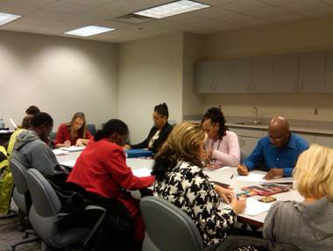
The Montgomery Chapter receives a majority of its revenue from educational events such as the Fall PDT and the Spring PDT. The table and graph include the various sources of revenues and expenses for the following program years. Expenses in 2022 for Education increased due to having a live/hybrid spring conference and having to pay for a vendor to assist with the technology to facilitate the conference. All educational programs went back to live person events causing an increase in Education expenses. The increase in Awards/Scholarships is due mostly to timing as the Scholarships are awarded in May, but not paid out until June 1.
Link to Montgomery Chapter CCR on website: www.montgomeryaga.org

Montgomery Chapter Revenues and Expenditures

Expenses | Program Year 2022 | Program Year 2021 | Percentage of Change
Awards/Scholarships | $8,725.00 | $3,544.75 | 146%
Education | $15,988.00 | $125.00 | 12690%
Webpage Technology | $1,765.00 | $1,794.27 | -2%
Miscellaneous | $7,535.00 | $8,928.44 | -16%
Totals | $34,013.00 | $14,392.46 | 136%

Revenues | Program Year  2022 | Program Year  2021 | Percentage of Change
Education | $47,072.00 | $8,295.00 | 467%
Meetings | $53.00 | $5.00 | 960%
Membership | $985.00 | $1,632.50 | -40%
Sponsorships | $1,100.00 | $0.00
Miscellaneous | $5,512.00 | $4,450.62 | 24%
Totals | $54,722.00 | $14,383.12 | 280%



Membership Committee
With the sudden drop in membership, we have to find out what we can do to make membership more attractive and "worth" the money. Several of our members who pay their own dues have said that they had to choose between expenses and unfortunately AGA did not make the cut. AGA Montgomery has needs to reach out to the other schools in the area. We get the young professionals to join but we want them to be more involved in the chapter so that once they get into their career, AGA is in their DNA. The goals of this committee are:
- To retain current members and provide promotional materials on the benefits of being an AGA member. To spotlight successful members in the Chapter Newsletter. To contact retired members and encourage them to renew their membership.
- To engage and support the young professionals, colleges and universities by providing social development and educational opportunities that are specifically targeted to and hosted by the young professionals and college students.
Certified Government Financial Manager
The CGFM Committee will promote the CGFM certification and assist candidates in preparing for the exams and act as a resource for CGFM information while increasing CGFM candidates. The goals of this committee are:
- To develop strategies to increase the number of CGFM candidates, by providing study groups and supporting materials to prepare and pass all the CGFM examinations.
- To display brochures for luncheons, seminars, social media and the chapter website, also assist in identifying CPE opportunities through online study, seminars, and self-study, publish member achievements in the chapter newsletter, local papers, websites and social media.
- To communicate and coordinate with other committees in identifying, supporting and recognizing new CGFM candidates.
Education Committee
The Education Committee is challenged with offering an increasing number of continuing educational opportunities for AGA members. The Education Committee goals are:
- To increase the number of CPE credits offered for lunch and learns and professional training events through virtual platforms and hybrid events. Also promote the webinars and educational events hosted by AGA National and Journal Online quizzes.
- To partner with other organizations to increase the number of participants thereby making it more cost effective to attend educational events.
- To include Chapter educational events on the National AGA online calendar of events, social media, brochures, and the Chapter website.
Community Service Committee
The challenges of this committee are to increase, the visibility of community service projects to members and prospective members. The goals of this committee are to:
- Encourage participation in upcoming projects planned for the current program year, increase social media coverage, and highlight sponsored organizations, and how they are assisted.
- Showcasing the organizations in the Chapter’s newsletters, social media, and websites with testimonials, reach the local community by serving small organizations, encourage more donations, and community service hours.

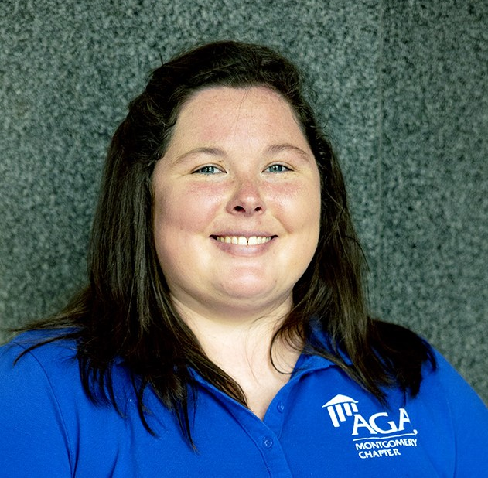

What’s Next? Challenges Moving Forward

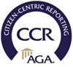
President Leigh Dailey
Program year 2022-2023

We would like to hear from you
Do you like this report? If you would like to see other information or if you would like more information on our services, visit our website at: www.montgomeryaga.org
Follow us on: Facebook, Twitter, and Linkedin

Chapter Office Directory
President Jonathan West
President-Elect Leigh Dailey
Treasurer LaTreeka Williams
Financial Sec. Kelsey Woodham
Secretary Charlene Daniel
Past President Nicole Boswell
NCC Rep. Courtney Bruce
“Travel into AGA’s Virtual World”

