Citizen Centric Report
Report to our Members
Montgomery AGA Chapter
Program Year 2020-2021



Contents
Overview Page 1
Performance Measurers Page 2
Finances Page 3
What is Next? Page 4
Message from our Chapter President
The theme for the 2020-2021 program year was “Travel into AGA’s Virtual Word: Adapting to the New Normal”. The Montgomery Chapter began the program year with a virtual lunch and learn. The attendees were educated on different types of video conferencing platforms.
During the program year the Chapter provided other virtual lunch and learn presentations with such topics as: COVID: Where are we, how we got her and when will it end.; Increase Your Confidence, Enhance Your Career; Audit controls and Red Flags for Bots; a Financial Workshop and a panel discussion to celebrate CGFM month. The CGFM Committee also had a “Drive- By Celebration” to recognize the members with the CGFM designation.
The Montgomery Chapter held its annual Fall and Spring Professional Development Training via ZOOM. The Professional Development Training for the Fall included the topics of: The Economic Impact of COVID- 19 Pandemic; Coronavirus Relief Funds Lessons Learned; and How Nonprofits are Helping Governments and Other Entities During COVID-19.
The Professional Development Training for the Spring PDT included the topics of: Ethics; Rise of the Home Office: Safeguarding Against Cyber Crime and Fraud; and The Visible Financial Effects of COVID-19. During the Fall and Spring PDT the Community Service Committee featured various local charities and their sponsors.
The Montgomery Chapter sponsored its second Accounting Student Essay Contest with a scholarship awarded to the winner. The Montgomery Chapter awarded scholarships and honorable mentions to ten students during the virtual scholarship awards ceremony in May. This meeting also included the passing of the gavel and the swearing in of the new officers for 2021-2022 program year.
I would like to thank all the Chapter Board Members for their volunteerism, commitment and hard work during unprecedented times and our chapter members for their loyal support. We wish success to Jonathan West our 2021-2022 Chapter President as we still navigate through trying times with COVID-19. We encourage all members to remain active and stay involved with AGA and keep pursuing the next level of certification as a CGFM. It was truly humbling and blessed experience to serve as your 2020-2021 Chapter President.

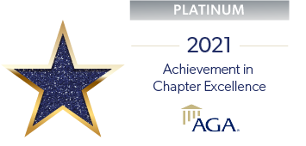
AGA Core Values
Service
Accountability
Integrity
Leadership

Chapter President, Nicole Boswell


Our Vision
Our Mission
Chapter Membership | FY 2021 | FY 2020
Government | 248 | 259
Private | 10 | 11
Retired/Lifetime | 5 | 8
Young Professional | 5 | 8
CGFM | 64 | 60
CPA | 37 | 37
CIA | 5 | 5
CFE | 7 | 7
Other | 15 | 11

The mission of AGA is to be the premier professional association in the advancement of accountability, transparency and leadership by promoting education, certification, innovation and collaboration across all levels of government and stakeholders.
The Montgomery Chapter of AGA is striving to become a leader in recruitment of new members and encourage participation in continuing education and certification.
Accomplishments and Performance Measurers

Key Performance Measurers
Montgomery Chapter Performance Measurers | Program Year 2021 | Program Year 2020 | Percentage of Change
Education | CPE Hours Offered | CPE Hours Offered
The Chapter held the luncheon meetings, Fall PDT and Spring PDT virtually due to COVID -19 concerns and mandates. This will account for the decrease in the number CPE hours offered during the program year. The CPE hours offered also includes, seminars offered by other AGA Chapters. | 16.30 | 32 | -49%
Certification | Number of new CGFM | Number of new CGFM
The CGFM Committee encouraged members to achieve the CGFM Certification through emails, newsletters, luncheon meetings and during the Fall PDT. The committee honored the members that had the CGFM designation during the month of March. The CGFM had a panel discussion for the March lunch and learn meeting. | 4 | 8 | -50%
Community Service | Projects | Projects
The Community Service had a great year. This committee partnered with the Brantwood Children Home, the Montgomery Children Home and the River Region United Way for donations during the Fall PDT. The Committee partnered with the Joy to Life Foundation and the Friendship Mission for donations during the Spring PDT. | 5 | 4 | 20%
Membership | Members | Members
The Membership Committee’s focus was customer service. This committee worked with the treasurer to make sure membership dues were paid in a timely manner and assisted in reconciling the financial reports. This committee was also committed to establishing a system for the members to communicate with the committee and receive a timely response. | 268 | 286 | -6%

Accomplishments
The Montgomery Chapter received the Platinum Award for program year 2020-2021 virtually during the 2021 National PDT for Chapter Recognition Points for Group A.
Mrs. LaTreeka Williams has been selected as the National Chair Representative for the Montgomery Chapter for program year 2021-2022.
The Accountability Committee received the Certificate of Excellence in Citizen Centric Reporting for the Montgomery Chapter Member Centric Report for program year 2019--2020.
The Community Service Committee featured charities were the Brantwood Children’s Home, the River Region United Way, the Joy to Life Foundation, and the Friendship Mission. The Community Service Committee received donations during the Fall and Spring PDT for these charities.
The Accountability Committee joined with the Membership Committee to host the Montgomery Chapter’s second Accounting Student Essay Contest for college students. The winner was Ms. Emily Willeford from Troy University. The subject of the essay was: COVID-19 on Accounting Changes and Reporting Requirements.
The CGFM Committee recognized the Montgomery Chapter members that have the CGFM designation in the month of March. The CGFM committee held a “Drive- By Celebration” with tokens of appreciation and published the names of the members in the CGFM newsletter.

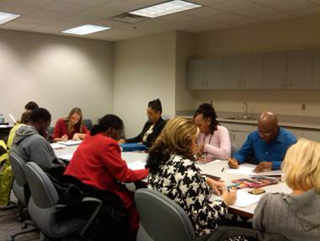
The Montgomery Chapter receives a majority, of its revenue from educational events such as the Fall PDT and the Spring PDT. The table and graph include the various sources of revenues and expenses for the following program years. The percentage of change in the financial reports are the result of COVID- 19 mandates and concerns. The Montgomery Chapter financial statements were not audited for Program Year 2020-20211.
Link to Montgomery Chapter CCR on website: www.montgomeryaga.org

Montgomery Chapter Revenues and Expenditures

Expenses | Program Year 2021 | Program Year 2020 | Percentage of Change
Awards/Scholarships | $3,544.75 | $2,251.73 | 36%
Education | $125.00 | $22,634.54
Webpage Technology | $1,794.27 | $1,988.95 | -10%
Miscellaneous | $8,928.44 | $21,374.66 | -58%
Totals | $14,392.46 | $48,249.88 | -70%

Revenues | Program Year  2021 | Program Year  2020 | Percentage of Change
Education | $8,295.00 | $29,430.00 | -72%
Meetings | $5.00 | $460.00 | -90%
Membership | $1,632.50 | $2,947.50 | -45%
Sponsorships | $0.00 | $2,750.00 | -100%
Miscellaneous | $4,450.62 | $7,259.62 | -39%
Totals | $14,383.12 | $42,847.12 | -66%

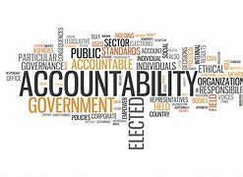

Membership Committee
The Montgomery AGA Chapter has 268 members. The goal is to retain the Montgomery Chapter membership and increase the membership to 300 members. The challenges of this committee are creating new and innovative ways to attract members and to help prospective members to see the advantages of membership in AGA. The goals of this committee are:
- To retain current members and provide promotional materials on the benefits of being an AGA member. To spotlight successful members in the Chapter Newsletter. To contact retired members and encourage them to renew their membership;
- To engage and support the young professionals, colleges and universities by providing social development and educational opportunities that are specifically targeted to and hosted by the young professionals and college students;
Certified Government Financial Manager
The CGFM Committee will promote the CGFM certification and assist candidates in preparing for the exams and act as a resource for CGFM information while increasing CGFM candidates. The goals of this committee are:
- To develop strategies to increase the number of CGFM candidates, by providing study groups and supporting materials to prepare and pass all the CGFM examinations;
- To display brochures for luncheons, seminars, social media and the chapter website, also assist in identifying CPE opportunities through online study, seminars, and self-study, publish member achievements in the chapter newsletter, local papers, websites and social media;
- To communicate and coordinate with other committees in identifying, supporting and recognizing new CGFM candidates.
Education Committee
The Education Committee is challenged with offering an increasing number of continuing educational opportunities for AGA members. The goals of this committee are:
- To increase the number of CPE credits offered through virtual lunch and learns and professional training events. Also promote the webinars and educational events hosted by AGA National and the Journal Online quizzes;
- To partner with other organizations to increase the number of participants thereby making it more cost effective to attend educational events;
- To include Chapter educational events on the National AGA online calendar of events, social media, brochures, and the Chapter website.
Community Service Committee
The challenges of this committee is to increase, the visibility of community service projects to members and prospective members. The goals of this committee are to:
- Encourage participation in upcoming projects planned for the current program year, increase social media coverage, and highlight sponsored organizations, and how they are assisted;
- Showcasing the organizations in the Chapter’s newsletters, social media, and websites with testimonials, reach the local community by serving small organizations, encourage more donations, and community service hours.

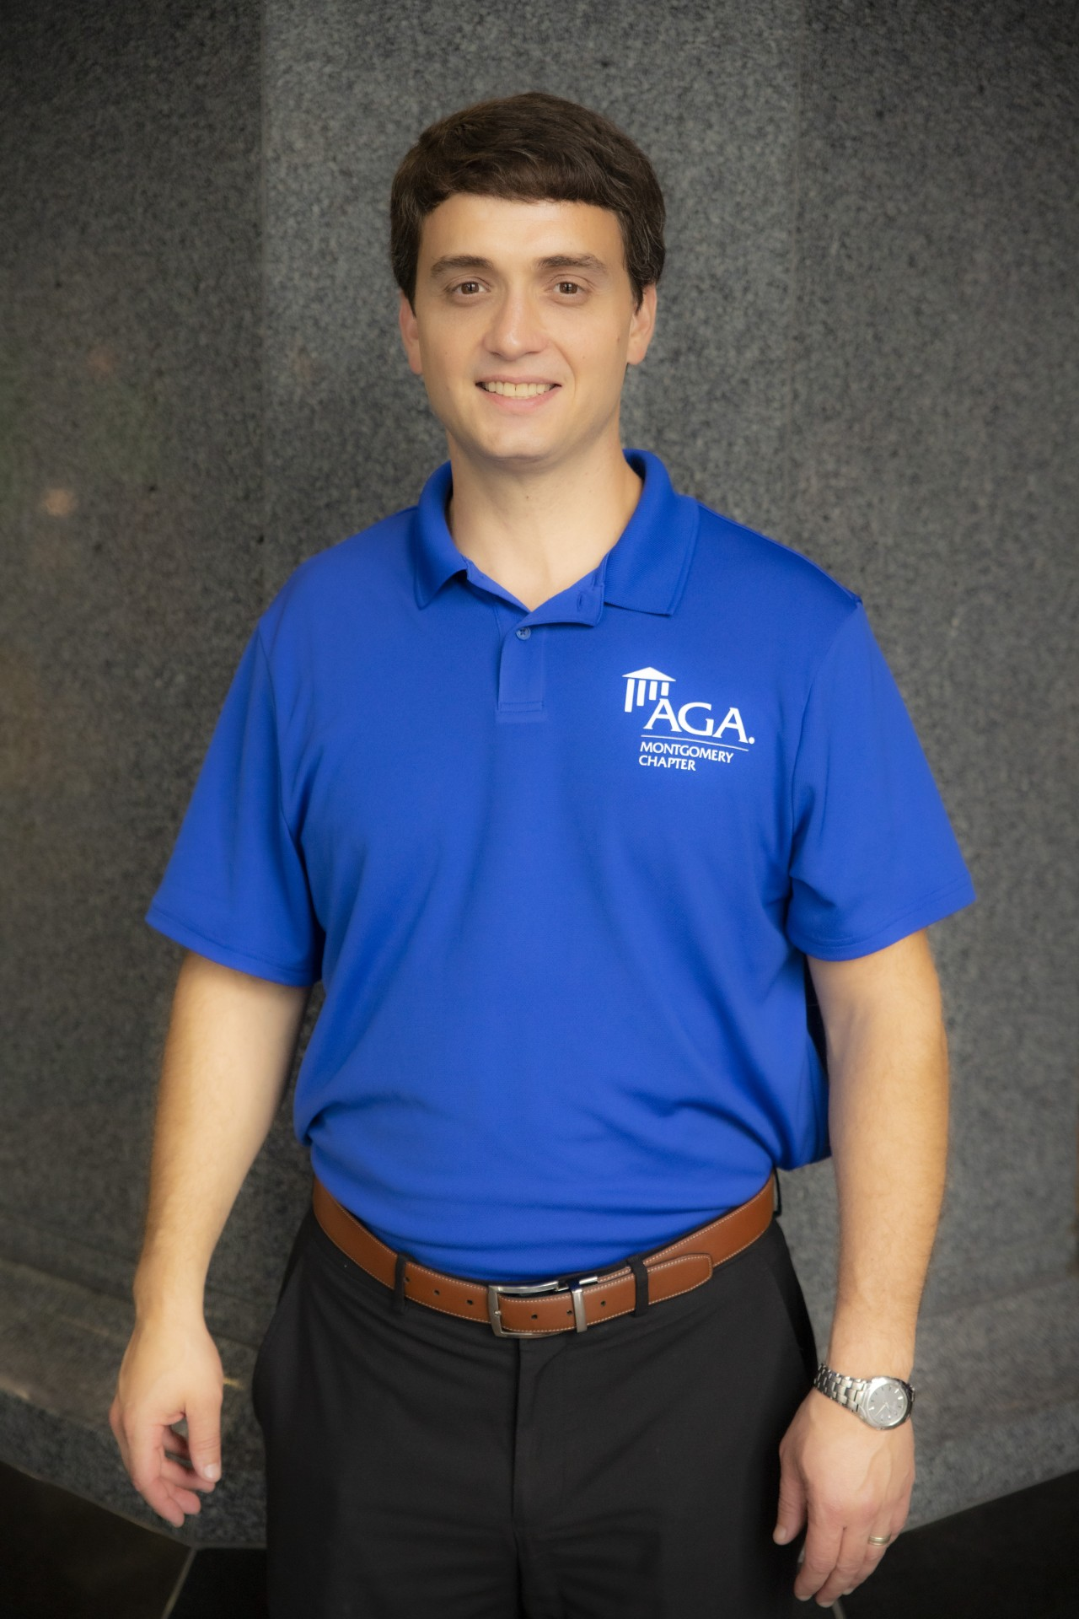

What’s Next? Challenges Moving Forward

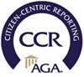
President Jonathan West
Program year 2021-2022

We would like to hear from you
Do you like this report? If you would like to see other information or if you would like more information on our services, visit our website at: www.montgomeryaga.org
Follow us on: Facebook, Twitter, and Linked

Chapter Office Directory
President Nicole Boswell
President-Elect Jonathan West
Treasurer LaShawn Pierce
Financial Sec. Charlene Daniel
Secretary Leigh Dailey
Past President LaTreeka Williams
NCC Rep. Courtney Bruce
“Travel into AGA’s Virtual World”

