February Newsletter
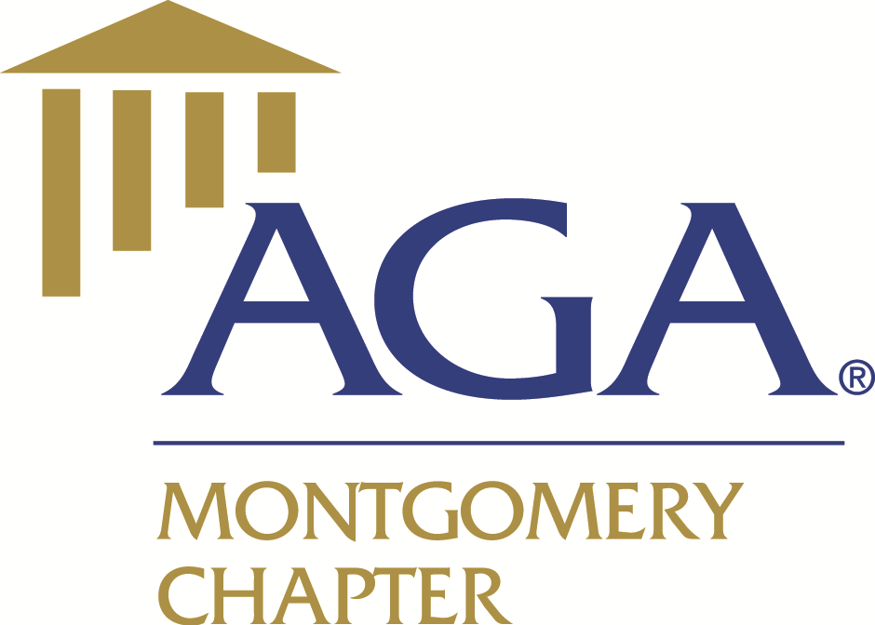

Association of Government
Accountants

Advancing Government Accountability

P. O. Box 1001
Montgomery, AL 36101

www.montgomeryaga.org

Jonathan West
President
president@montgomeryaga.org

Leigh Dailey
President-Elect
president-elect@montgomeryaga.org

Latreeka Williams
Treasurer
treasurer@montgomeryaga.org

Kelsey Woodham
Financial Secretary
financialsecretary@montgomeryaga.org

Charlene Daniel
Secretary
secretary@montgomeryaga.org

Nicole Boswell
Immediate Past President
president@montgomeryaga.org


Date: 2/25/2022

Nominations for 2022-2023
We are now accepting nominations for the Chapter Executive Committee and Committee leadership roles for the fiscal year ending 5/31/2023. If you are interested in serving or would like to nominate someone to service, please email secretary@montgomeryaga.org by March 11, 2022.
Positions to include:
The AGA Nominating Committee will meet in March and select one candidate for each of the positions above. If an election is necessary for any of the positions listed above, the chapters members will be provided an opportunity to cast a vote at the Chapter Meeting held in April. If you would like to serve but are not sure where, please e-mail us anyway and we will find a spot for you!
Accounting student Essay Scholarship
We are proud to announce Abigail Williams as the recipient of our Annual, Accounting Student Essay Scholarship. Abigail is a senior, at Auburn University Montgomery. She is an Accounting Major and will begin the Master of Accountancy program in the summer of 2022.

Scholarships

The Upcoming Fall Semester will be here before we know it. Our Chapter is proud to be able to continue to provide multiple scholarship opportunities.

Applications can be found at montgomeryaga.org AGA Scholarships
Scholarship Application deadline: Thursday, April 7, 2022
Scholarships will rage from $500 to $1,000 dollars

Available Scholarships include:

- Full-time State Employee Scholarship
- AGA Chapter Member or Child of a Chapter Member Scholarship
- Upcoming College Freshman Scholarship
- Financial Management Scholarship

We want to thank Dr. Delvin Seawright for his donation to the Scholarship Committee in the amount of $1,000! 100% of his donation will be added to the Chapters Annual Scholarship Budget.



Delvin D. Seawright, Ph.D., CPA (AL), CGMA, CGFM, a native of Montgomery, Alabama and former Montgomery AGA Chapter member, is an associate professor of accounting in the School of Accounting and Information Systems at Lamar University (LU) in Beaumont, Texas. He teaches financial and governmental accounting courses and researches topics related to corporate governance (auditing), accounting education, and business ethics. He has over 10 years professional governmental accounting experience with the State of Alabama. He received his Ph.D., M.S., and B.S. degrees in accounting from Morgan State University, Alabama State University, and Spring Hill College, respectively. Dr. Seawright is a servant-leader that is very active serving in various capacities within the LU, professional, and local communities. A current member of the Houston Chapter of AGA, he has served in various AGA capacities at the chapter, regional, and national levels since becoming a member in 2007. He recently completed four consecutive three-year terms (2009-2021) on the national Professional Ethics Board and is currently serving a three-year term (2021-2024) on the national Governance Committee. Twice (2012, 2013) a former recipient of the national AGA Full-Time Graduate Student Scholarship as a doctoral student, Dr. Seawright strives daily to live out the motto "To whom much is given, much is required." He resides in Houston, Texas.

Upcoming Local Chapter Events

CGFM Panel Discussion
Thursday, March 10, 2022
12:00PM – 1:00PM
Registration (montgomeryaga.org)
Member Rate: Free
Non-Member Rate: $5
Registration Cutoff: 3/7/2022: Tentative 1 CPEs
Please join us for our upcoming CGFM Panel Discussion. The topic “The Value and Benefits of the CGFM Certification”, moderated by Leigh Daily, CPA and AGA Montgomery Chapter President-Elect.

Spring PDT
Thursday, April 7, 2022
8:00AM – 4:00PM
Registration (montgomeryaga.org)
Member Rate $119 (Early bird $99 by 3/18/22)
Non-Member Rate $229 (Early bird $209 by 3/18/22)
Students ($30)
Registration Cutoff: 4/1/2022: Tentative 8 CPEs
Attend Live at Wynlakes Golf and Country Club or Virtually

Our speakers for the spring conference will include, Mayor Steven Reed, Dr. Keivan Deravi, The Acting Secretary of the Alabama Office of Information Technology Marty Redding, Chief John Archer of ALEA, and representatives from State Personnel and the State Comptroller’s Office.

Please check the Montgomery AGA Chapter website https://montgomeryaga.org/ to register for events and the most up to date information.

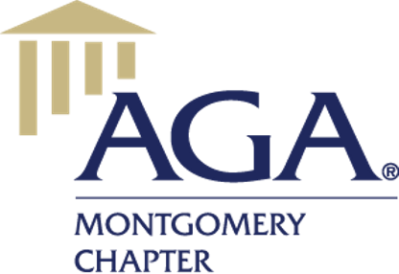
Upcoming National Events
Accounting Student
Essay Scholarship

Essay Application Packet

Sponsored by the Montgomery Chapter of the
Association of Government Accountants
WWW.MONTGOMERYAGA.ORG

Inaugural Women’s Forum
March 9, 2022
Attend Virtually only| 5 CPEs / FREE for AGA Members
Register at: Inaugural Women's Forum

PIO*CFO Summit National Conference
May 12, 2022
Attend in person or Virtually | 4 CPEs / FREE for AGA Members
Register at: PIO*CFO Summit

PDT 2022 AGA National Conference
July 17-20/ Anaheim CA
Attend in person or Virtually | 24 CPEs
Register at: PDT 2022 AGA National

Please check the National Chapter Website www.agacgfm.org to register for events and the most up to date information.

Special Thanks to our CEC and Team Leaders

Committee | Name |  | Committee | Name
Executive | Latreeka Williams |  | Accounting & CPE Administration | Angie Williams
Executive | Kelsey Woodham |  | Accounting & CPE Administration | Wandrell Williams
Executive | Leigh Dailey |  | Education | Rachel Chou
Executive | Charlene Daniel |  | Education | Sandi Taylor
Executive | Nicole Boswell |  | Historian/Records Retention | Suretta Davis
Executive | Jonathan West |  | Meetings & Registration | Sherita Pace
Accountability | Carmen Leonard |  | Meetings & Registration | Tashundrea Patterson
Accountability | Andrew McLelland |  | Meetings & Registration | Reneta Poole
Audit | Matthew Watson |  | Meetings & Registration | Tamaya Roberts
Audit | Lakisha Davis |  | Meetings & Registration | Nicole Skipper
Awards & Sponsorship | Subrena Davis |  | Membership | Keitha Parker
Awards & Sponsorship | Liz Burgess |  | Membership | Yeteva Johnson
Bylaws & Procedures | Tashantia Stewart |  | Scholarships | Greg Sims
Careers | Saketa Moore |  | Scholarships | Carolyn Rhodes
CGFM | Renee Reese |  | Scholarships | Patricia Wilson
Communication & Webmaster | Courtney Bruce |  | Photography Committee | Mark Vincent
Community Service | Charlene Daniel |  | Photography Committee | Carla Williams


The State Initiative Program was developed by the AUM School of Accountancy and the State Government Members of the AUM Accounting Advisory Board. The program development was driven by the installation of the State of Alabama’s new accounting systems and the need for state employees to receive formal education to develop additional accounting knowledge and skills. This State Initiative continues the AUM commitment to facilitate the educational needs of State of Alabama’s employees.
The State Initiative Program consists of five accounting courses as required by the State of Alabama Personnel Classifications of Account Clerk and Accounting Technician.
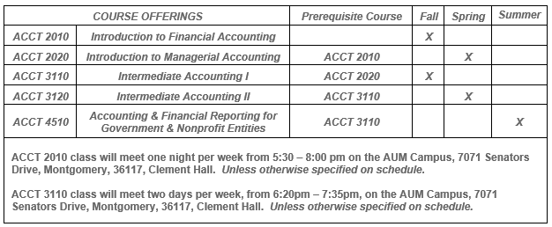
How state employees should apply to the program:
- Submit the Request form and proof of State Employment (copy of state ID badge) to Angie Corbett, acorbett@aum.edu.
- Apply online for admission to AUM as an unclassified student for the State Employee Accounting Courses (SEAC) status @ https://aum.elluciancrmrecruit.com/admissions/pages/welcome.aspx. Choose “Create an Undergraduate Account”.
- Submit the required transcripts, (whichever is most recent, high school or college) or GED with score sheet, to the AUM Office of Admissions. You must contact your high school or college and request your transcripts be sent to the AUM Office of Admissions. All required documentation must be received before your application can be processed. You will receive an email notifying you of your acceptance, which will include your student ID number (necessary for setting up AUM email and course registration).
Any questions regarding admissions requirements, admissions acceptance and/or transcripts should be directed to the AUM Office of Admissions at 244-3615.
Tuition Cost and Installment Plan Available for State Employees
The tuition cost per course for State Employees is currently $549.50. That price is based on half of AUM’s current tuition rate (for a 3 credit hour course) plus two fees. Increases in tuition, if any, occur during fall semesters. Previous tuition increases have only raised the State Initiative tuition by approximately $15. This price does not include the cost of the textbook.
Any questions regarding payments or due dates should be directed to AUM Student Accounts Office at 244-3286.
All other program questions should be directed to Angie Corbett, Senior Program Associate, acorbett@aum.edu or (334)244-3274.

